MERN-Stack
NOTE:This documentation is based on just a single youtube tutorial only to get to understand how MERN-stack works. I’ll start learning the details from the beginning after I’m done with this tutorial.
In Terminal:
- cd .\backend\
- npm init -y
- npm install express(@VERSION) (for instance: express@4.18.2)
create server.js :
import express from "express"; // package.json --> "type": "module"
const app = express();

app.listen(5001, () =>{
console.log("Server started on PORT: 5001");
});
- app.listen() starts the Express server and makes it listen for incoming HTTP requests (the API requests). In this case, it starts on port 5001. (http://localhost:5001)
- Note: or the import to work, you must change the “type” value to “module” in package.json
Go to package.json and change these values:
…
"type": "module",
"main": "server.js",
"scripts": {
"dev": "npm server.js", This thing is called when we run “npm run dev”
Then we can have our first API example in server.js for a simple get request.
app.get("/api/notes", (req, res) => {
res.status(200).send("Success"); // or res.send(“Success”);
});
http://localhost:5001/api/notes will return the message “Success”.
NOTE: It is better to have app.listen() at the bottom for a better readability and to avoid confusion.

There is a problem.
Now changing any part of our code isn’t applied until we Ctrl + C in the terminal and restart the server (npm run dev). To fix that, we install nodemon.
In Terminal:
- npm install nodemon -D
And then in package.json we change:
"scripts": {
"dev": "nodemon server.js", This thing here is called when we “run npm run dev”

Best practice
Instead of having all the app.get() methods in the server.js file, we can have a cleaner code by making another JavaScript file and keep them there. Then we can access them using express.Router().
server.js:
import express from "express"; // package.json --> "type": "module"
import notesRoutes from ".routes/notesRoutes.js";

const app = express();

app.use("/api/notes", notesRoutes); // uses the routes in the file instead of having them all here

app.listen(5001, () =>{
console.log("Server started on PORT: 5001");
});
/routes/NotesRoutes.js: (note that /routes/ is the folder name holding all the routes)
import express from "express"

const router = express.Router();

router.get("/", (req, res) => {
res.status(200).send("You just fetched the notes.");
});
router.post("/", (req, res) => {
res.status(201).json({message:"Note created successfully!"});
});
router.put("/:id", (req, res) => {
res.status(201).json({message:"Note created successfully!"});
});
router.put("/:id", (req, res) => {
res.status(200).json({message:"Note deleted successfully!"});
});

export default router;
(We have switched to Json for message delivery since it’s better.)

We can also go further and move the controllers (all the router.get/router.put/etc.) onto a separate file as separate functions:
- create ./backend/controllers/notesController.js :
export function getAllNotes(req, res){
res.status(200).send("You just fetched the notes.");
}

export function createNote(req, res){
res.status(201).json({message:"Note created successfully!"});
}

export function updateNote(req, res){
res.status(201).json({message:"Note updated successfully!"});
}

export function deleteNote(req, res){
res.status(200).json({message:"Note deleted successfully!"});
}
- change notesRoutes.js :
import express from "express"
import { createNote, deleteNote, getAllNotes, updateNote } from "../controllers/notesController";

const router = express.Router();

router.get("/", getAllNotes);

router.post("/", createNote);

router.put("/:id", updateNote);

router.put("/:id", deleteNote);

export default router;
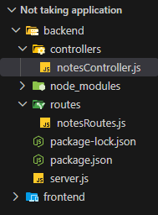
This is how our hierarchy looks at this point:
And we can also put them in the src folder for a cleaner project:
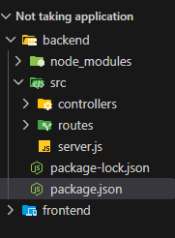
And change package.json accordingly:
"scripts": {
"dev": "nodemon /src/server.js",
"start": "node src/server.js" This thing is used when the server is implemented and not in davelopment (ignore for now)
},

Installing MongoDB to connect to our database
- run npm install mongoose(@VERSION can be used)
note: you can also use npm install mongodb but mongoose is better.
- Copy the connection link during the process of making a cluster on the MongoDB dashboard.
mongodb+srv://<user>:<password>@cluster0.34pw2pi.mongodb.net/<db_name>?appName=Cluster0
- Use it in a function to initialize a connection.
- For a better readability we make a file under a new folder accordingly: ./config/db.js
import mongoose from "mongoose"

export const connectDB = async () => {
try{
await mongoose.connect("PASTE THE CONNECTION LINK HERE");
console.log("MONGODB CONNECTED SUCCESSFULLY");
} catch (error){
console.log("ERROR CONNECTING TO MONGODB", error);
process.exit(1); // 1: exit with failure, 0: exit with success
}
}
- Then in server.js (our main file) add these:
import { connectDB } from "./config/db.js";
const app = express(); was already there. ignore this.
connectDB();

There is a problem
By just pushing this file to github, everyone will have the link to our database by just reading that line! To avoid that:
- Make: /backend/.env
- Write:
MONGO_URI=mongodb+srv://<user>:<password>@cluster0.34pw2pi.mongodb.net/<db_name>?appName=<clustername>

- run npm install dotenv in terminal
- Add this to server.js:
import dotenv from "dotenv";
dotenv.config();
- Then change the db.js file accordingly:
import mongoose from "mongoose"
export const connectDB = async () => {
try{
await mongoose.connect(process.env.MONGO_URI);
console.log("MONGODB CONNECTED SUCCESSFULLY");
} catch (error){
console.log("ERROR CONNECTING TO MONGODB", error);
process.exit(1); // exit with failure
}
}
- Then we make sure our env file is hidden and inivisble in our github repository. (using gitignore)

Making a model for notes
- /src/models/Note.js :
import mongoose from "mongoose";
// 1st step: create a schema
// 2nd step: create a model based off of that schema
const noteSchema = new mongoose.Schema(
{
title:{
type: String,
required: true
},
content:{
type: String,
required: true
}
},
{ timestamps: true } // createdAt, updatedAt
);
const Note = mongoose.model("Note", noteSchema); // creates a Note model based on noteSchema
export default Note;
Remember the <db_name> section in the mongodb link? This is where it appears:
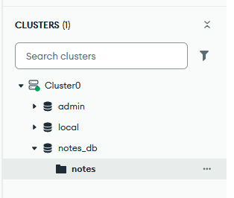

Postman is one of the coolest things ever.
With postman we can do different http requests quickly and give input and receive a response. It is extremely useful for testing our API and the correctness of it.
Take the below code as an example:
export async function createNote(req, res){
try{
const {title, content} = req.body; The body of the request message we send to the server
const note = new Note({title:title, content:content}); Make a new note using the request’s body

const savedNote = await note.save(); the actual part that sends the insert command
res.status(201).json(savedNote); return HTTP 201 (updated) and show the saved note)
} catch(error){
console.error("Error in createNote controller", error);
res.status(500).json({message:"Internal server error"});
}
}
To be able to read “req” data (the data we send to the server in the body), we add this line to server.js:
connectDB(); was already there. Ignore this.

// middleware
app.use(express.json()); // lets us use the req body (the data we send to the server) in our code. (In the controllers)
// Otherwise "req" would be null all the time.

app.use("/api/notes", notesRoutes); was already there. Ignore this.

Middleware
Middleware is a function that sits between the incoming request and your final route handler. Middleware runs on the way IN, before route handler processes the request.
app.use(); is used to add a middleware.

Examples
app.use(express.json());
- This is a built-in Express middleware that parses incoming request bodies. When your frontend sends a POST/PUT request with JSON data (like {title: "...", content: "..."}), it arrives as a raw string/buffer — this middleware reads that, parses it into an actual JS object, and attaches it to req.body

app.use((req, res, next) => {
console.log(`New Request: method: ${req.method} URL: ${req.url}`);
next();
})
- This is a custom middleware. Every single request that hits the server — no matter which route — passes through here first, and it logs the HTTP method (GET, POST, etc.) and the URL that was hit.

app.use("/api/notes", notesRoutes);
- This one's slightly different — it's not a generic "run on every request" middleware, it's mounting the router at a specific path prefix. It means: any request whose URL starts with “/api/notes”, hand it off to the notesRoutes router to figure out the rest.
Middleware is extremely useful since it allows us to implement features like authentication, rate limits (to avoid spam requests, DOS/DDOS attacks, etc.) and so on.
ERROR 429: Too Many Requests.

Upstash
For rate limiting we can use Upstash.
- Login on their website
- Make a database
- Put these values you find on the upstage database page in the env file:
- UPSTASH_REDIS_REST_URL=https://cool-fj3something.upstash.io
- UPSTASH_REDIS_REST_TOKEN=SomeLongTokenHere
- In the terminal run: npm install @upstash/ratelimit@2.0.5 @upstash/redis@1.34.9
- Make src/config/upstash.js
import {Ratelimit} from "@upstash/ratelimit";
import {Redis} from "@upstash/redis";
import dotenv from "dotenv";
dotenv.config();
// create a ratelimiter that allows 10 requests per 20 seconds
const ratelimit = new Ratelimit({
redis: Redis.fromEnv(),
limiter: Ratelimit.slidingWindow(100, "60 s"), 5 requests every 10 seconds
});
export default ratelimit;
- Make src/middleware/rateLimiter.js
import ratelimit from "../config/upstash.js";
const rateLimiter = async (req, res, next) => {
try{
const {success} = await ratelimit.limit("my-limit-key");
if (!success){
return res.status(429).json({message:"Too many requests, please try again later."});
}
next();
} catch(error){
console.log("Rate limit error", error);
next(error);
}
}
export default rateLimiter;

Front-end
Setting up the frontend:
- Open a terminal and head to ./frontend/
- Run npm create vite@latest .
- Choose: React, JavaScript
- Run npm install react-router Used for switching between webpages
- Run npm install react-hot-toast Used for popup notifications (succes, fail, etc.)
In ./frontent/src/
- Delete ./frontend/src/assets/
- Delete App.css
- Clear App.jsx
- Clear index.css
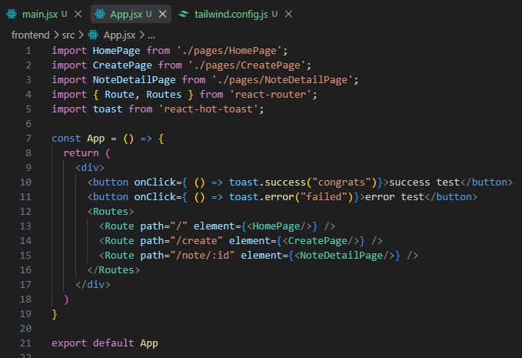
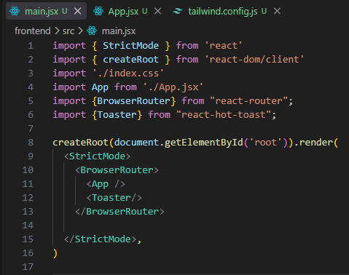
We start by making these files:

<Toaster/> in main.jsx is like a layer on top of everything (since main.jsx is our root file) and it allows the child layers (like App.jsx) to access the toast notification messages and use its methods.
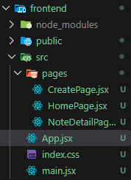
And we make a folder holding our pages (which we are going to develop later on).
We use a <Router> tag with <Route> tags inside of it for different routes on our website. This is how we connect our pages together.

tailwindcss
We have to install tailwindcss since it allows us to use css inside of our jsx files instead of having to make a separate css file for each.
Open terminal at ./frontend/
- Run npm install -D tailwindcss@latest @tailwindcss/vite
- Then put these in vite.config.js:
import { defineConfig } from 'vite'
import react from '@vitejs/plugin-react'
import tailwindcss from '@tailwindcss/vite'

export default defineConfig({
plugins: [react(), tailwindcss()],
})
- For the final step, add these to index.css:
@import "tailwindcss";

daisyUI
Now we install DaisyUI for shorter code, better looks, and faster UI.
- Run npm install -D daisyui@latest at ./frontend/
- Change the tailwind.config.js to:
import daisyui from "daisyui";
/** @type {import('tailwindcss').Config} */
export default {
content: [
"./index.html",
"./src/**/*.{js,ts,jsx,tsx}",
],
theme: {
extend: {},
},
plugins: [daisyui],
}
To select a specific theme:
- Go to https://daisyui.com/docs/themes/ and choose a theme you would like to use.
- Add then add this (+ the theme you want) to index.css:
@plugin "daisyui" {
themes: abyss --default, dark, light; The themes you want to use (LOOKUP from daisyui.com)
}
Note: the chosen theme becomes the whole frontend’s theme. You can change different parts of each page by just adding data-theme=”THEME_NAME” to that section’s tag.

Icons
Since we will use many different icons, it is better if we install a package that has them and use those instead.
At ./frontend/ :
- run: npm install lucide-react
- run: npm install axios To replace our fetch API with axios (for later)

Navbar.jsx
It’s a best practice to make a components folder for footer, header, navbar, etc.
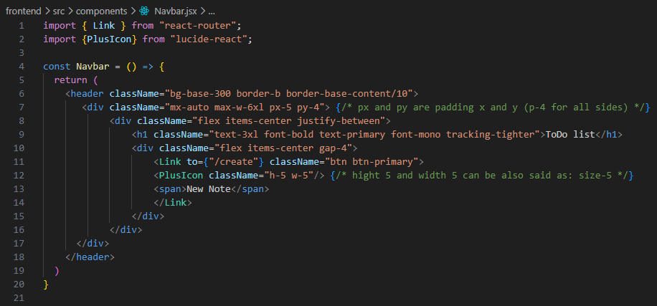
Notice how Link is imported from react-router and how <Link to={“/create”}> is used to make a link to our other route (webpage).

RateLimitedUI.jsx
A component to show the user they have hit the 429 (too many requests) error for spamming.
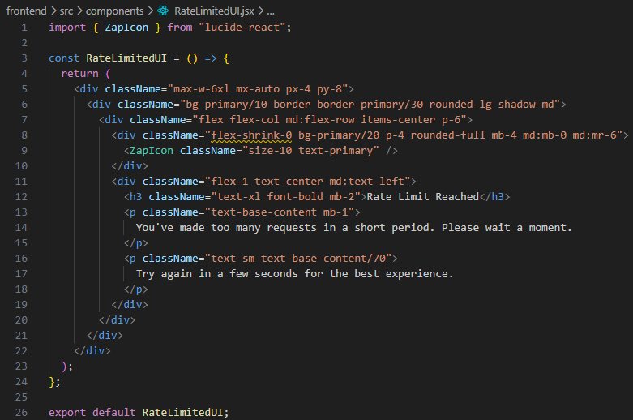

Cross-Origin Resource Sharing (CORS)
When a website tries to get data from another website - like your frontend calling an API on a different domain-the browser might block it for security reasons.
Example:
- Frontend at: http://localhost:3000
- API backend at: http://api.example.com
To fix it:
- Go to ./backend/ in terminal and run npm install cors
- Add these to server.js (backend) :
import cors from "cors";
app.use(cors({
origin: "http://localhost:5173", The address of the API (can have multiple in array)
}));
NOTE: app.use(cors()); must come before every other middleware.

Homepage.jsx
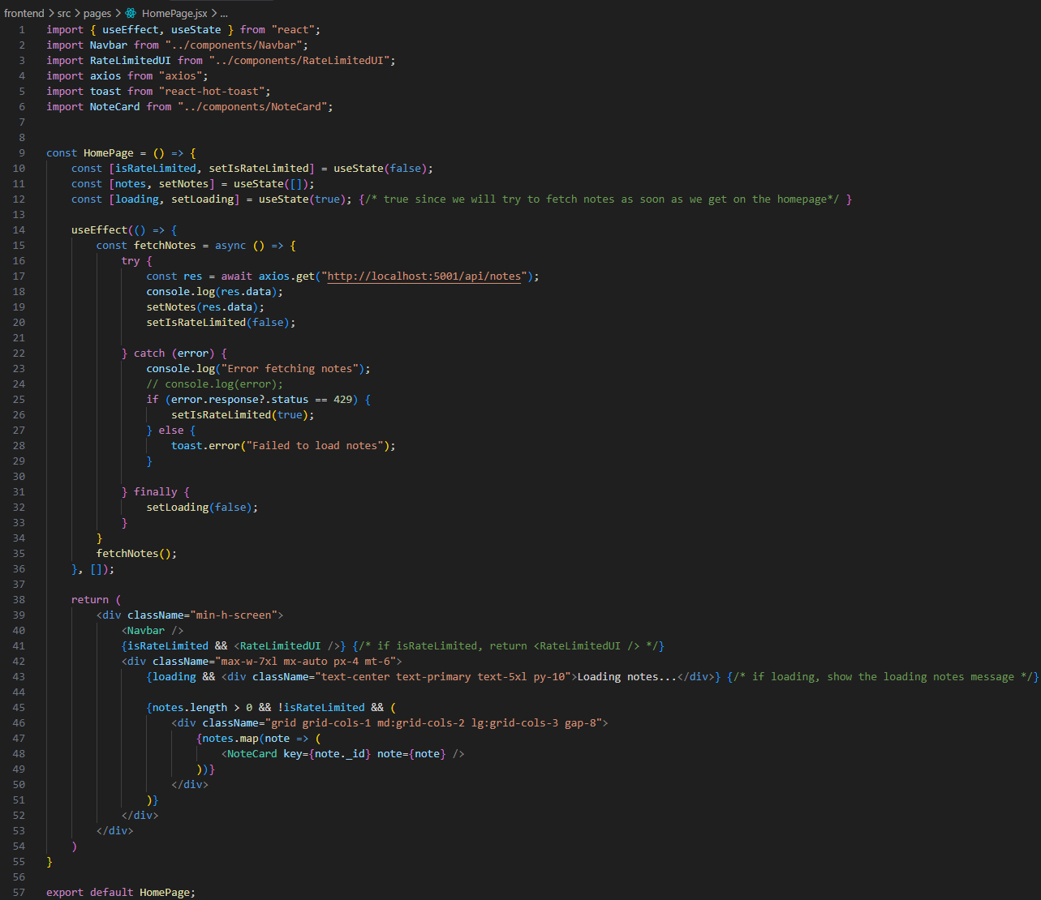
Instead of using axios.get(“http://localhost:5001/api/notes”); we can use this other method:
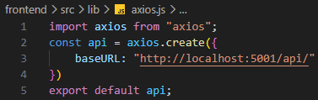
And then do:
import api from "../lib/axios";
…
… api.get("/notes");

CreatePage.jsx
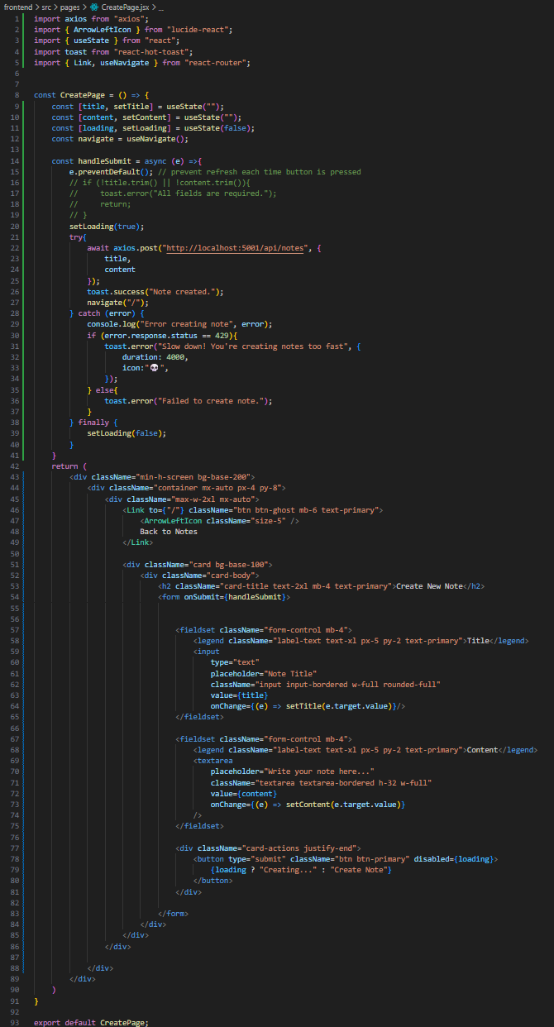

NoteDetailPage.jsx
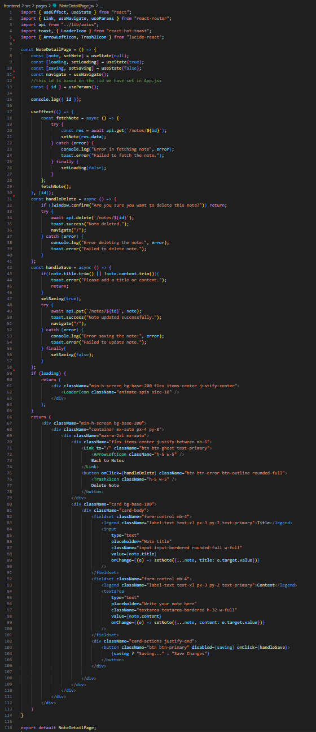

Deploying
After finishing all the pages, we need to make sure that we have our .gitignore file at the root folder.
It MUST ignore the .env file and also the node_modlues:
# Logs
logs
*.log
npm-debug.log*
yarn-debug.log*
yarn-error.log*
pnpm-debug.log*
lerna-debug.log*

node_modules THIS IS VERY IMPORTANT
dist
dist-ssr
*.local

# Editor directories and files
.vscode/*
!.vscode/extensions.json
.idea
.DS_Store
*.suo
*.ntvs*
*.njsproj
*.sln
*.sw?
.env THIS IS VERY IMPORTANT
Now we do need to list the dependencies needed since we are not including the node_modules directory. For that, we do:
- In the terminal at root folder run: npm init -y
A new file called package.json will be made and we have to change the “scripts” section to this for deployment on the server:
"scripts": {
"build": "npm install --prefix backend && npm install --prefix frontend && npm run build --prefix frontend"
},
This is what the whole file will look like:
{
"name": "mern-stack-todo-list",
"version": "1.0.0",
"description": "",
"main": "index.js",
"scripts": {
"build": "npm install --prefix backend && npm install --prefix frontend && npm run build --prefix frontend"
},
"repository": {
"type": "git",
"url": "git+https://github.com/Ariocodes/MERN-Stack-ToDo-list.git"
},
"keywords": [],
"author": "",
"license": "ISC",
"type": "commonjs",
"bugs": {
"url": "https://github.com/Ariocodes/MERN-Stack-ToDo-list/issues"
},
"homepage": "https://github.com/Ariocodes/MERN-Stack-ToDo-list#readme"
}

